**Production Function**

**“Production function is creating Utility”**

In Economics,

“Production function means transformation of input into output”

**Types of production function**

**Long Run Production Function**

**(Variable)**

**Short Run Production Function**

**(FIXED)**

**Types of Products**

**Total Product:-** It is sum of total quantity of output produced by variable factors along with units of fixed factors.

**Average product:-** It refers to the output per unit of variable factors.

**AP = TP/L**

Where, AP = Average Product, TP= Total Product, L=Labor

**Marginal Product:-** It refers to the additional product which can be derived by employing one more unit of variable factor.

**MP= TPL(n) – TPL(n-1)**

|  |  |  |  |  |
| --- | --- | --- | --- | --- |
| **Fixed Factor (Land)** | **Variable Factor (Labor)** | **TP** | **AP** | **MP** |
| **1** | **1** | **20** | **20** | **20** |
| **1** | **2** | **50** | **25** | **30** |
| **1** | **3** | **90** | **30** | **40** |
| **1** | **4** | **116** | **29** | **26** |

**MP=∆TP/∆L**

**Law of variable proportion or law of return to scale or law of diminishing return**

* It is related to short run product.
* As we increase the quantity of only input variables keeping other factors constant,
  + then the total product initially increase at an increasing rate,
  + Then at decreasing rate and
  + Finally at a negative rate.
* In other words as we employ more and more units of variable factor with the given fixed factor, the proportion between variable factor to total product change in such a way that the resulting output (MP)
* At first increases then diminishes and finally becomes and then negative.

**Schedule of law of variable proportion:-**

|  |  |  |  |  |
| --- | --- | --- | --- | --- |
| **Fixed factor (Land)** | **Variable factor**  **(Labor)** | **TP** | **AP** | **MP** |
| **1** | **1** | **100** | **100** | **100** |
| **1** | **2** | **210** | **105** | **110** |
| **1** | **3** | **330** | **110** | **120** |
| **1** | **4** | **420** | **105** | **90** |
| **1** | **5** | **490** | **98** | **70** |
| **1** | **6** | **490** | **81.6** | **0** |
| **1** | **7** | **488** | **69.7** | **-2** |

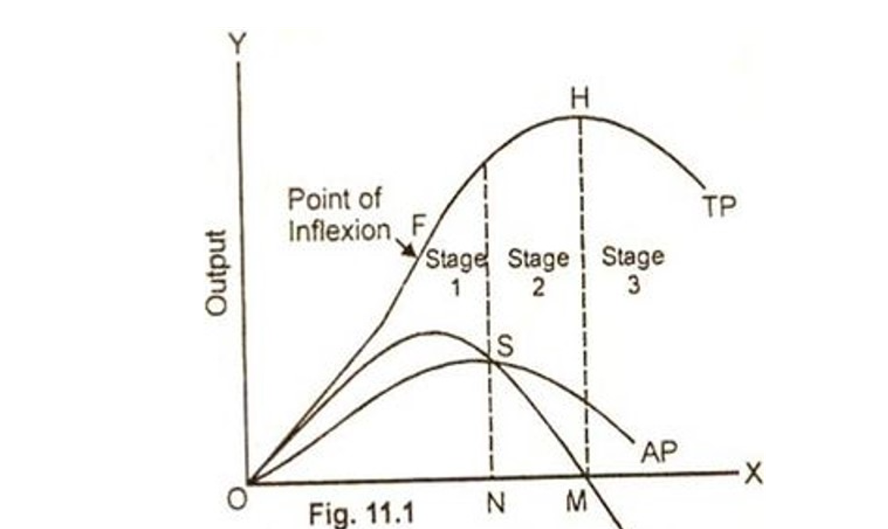

**Assumptions of law of variable proportion:-**

* The firm operates in the short run. This means only one factor of production is variable, while all other factors are constant or fixed.
* The technique of production does not change
* All units of the variable factors are equally efficient.
* Factors of production are not perfect substitutes of each other.
* Labor can not be fully replaced capital or vice-versa.

**Causes of variable proportion:-**

**Causes of increasing return:-**

1. Better utilization of fixed factor
2. Better co-ordination between the factors
3. Increase in efficiency of labor

**Causes of diminishing return:-**

1. Fixity of the factors
2. Imperfect substitutes of factors
3. Less co-ordination between the factors

**Causes of negative return:-**

1. limitation of fixed factors
2. Poor co-ordination between the factors
3. Decrease in efficiency of factors

**Meaning of Cost**

* In order to produce output any firm need to employ inputs or factors of production like- land, labor, capital and organization etc.
* The factors of production earn not a free goods but economic goods.
* They are to be paid, when their services are utilized in the production process.
* Land gets rent, labor gets wages, capital gets interest, and organization gets profit and so on.
* cost of production therefore, is the payment made to the factors of production for rendering their services in the production process.

**Types of cost Concepts:-**

1. **Opportunity cost:-**

The opportunity cost also known as alternative cost is the value of the choice not obtained or **benefits forgone to choose best alternative among many alternatives.**

1. **Marginal Cost:-**

* The increase or decrease in the total cost of production for one additional unit of an item is marginal cost.
* In economics marginal cost is the change in the total cost arises when the quantity produced is increased by one unit i.e.
* It is the cost producing one more unit of goods.
* For example- the total cost of producing 100 cell phone is Rs. 50000. when the firm produce one more cell phone i.e. 101, the total cost become Rs. 54000
* Thus the marginal cost of producing cell phone is Rs. 4000 (Rs.54000 - Rs.50000).

|  |  |  |
| --- | --- | --- |
| **Qnty. of O/P (Q)** | **TC** | **MC** |
| 0 | 20 | - |
| 1 | 24 | 04 |
| 2 | 27 | 03 |
| 3 | 30 | 03 |
| 4 | 33 | 03 |
| 5 | 35 | 02 |

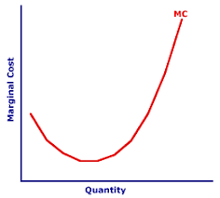

1. **Incremental cost:-**

* Incremental cost is closely related to the concept of Marginal cost but with the relatively wider connotation.
* It refers to total additional cost associated with the decision to expand output or to add a new variety of product etc.
* It is the change in total cost as a result of change in the methods of production or distribution such as use of improved machinery, addition to a product, use of improved technology or selection of additional sales channel.
* For example- if a company’s total cost increases from Rs.530000 to Rs.580000 as a result of increasing its labor hours , from 8 to 10 hours per day, the incremental cost of 2 extra labor hours is Rs.50000 (Rs.580000 – Rs.530000)

1. **Implicit & Explicit Cost:-**

* **An implicit** cost also called an **imputed cost, implied cost or notional cost** is the opportunity cost equal to what a firm must give up in order to use a factor of production for which already owns and thus does not pay the rent.
* **Explicit cost** means, the cost of those factors of production whose payment is made to the outsider or 3rd party. Explicit cost is also called **paid-out cost** or **out of pocket cost**.

1. **Short run cots:-**

* **Short run is a time period in which all cost can not be varied.**
* **Some inputs are fixed and other inputs remain variable during the short run.**
* **Therefore short run cost of production can be divided into two parts.**

**5(a). Fixed cost(TFC):-**

* **Total fixed cost is the cost that a firm incurs to employ the fixed inputs (like- machinery, building etc.) is called fixed cost or total fixed cost.**
* **Whatever amount of output the firm produces, the cost remains fixed for the firm in short run.**
* **The following table indicates that change in the quantity of output causes no change in fixed cost.**
* **Assume when output is 0 unit, fixed cost is Rs.20.**

|  |  |
| --- | --- |
| **Units of**  **production** | **Fixed cost (in Rs.)** |
| **0** | **20** |
| **1** | **20** |
| **2** | **20** |
| **3** | **20** |
| **4** | **20** |
| **5** | **20** |

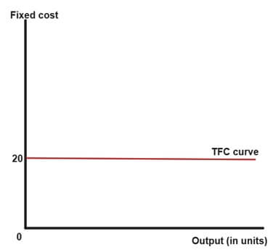

**5(b). Variable cost(TVC):-**

* **The cost that a firm incurs to employ the variable inputs (like- raw material, wages to labor, fuel or power etc.) is called the variable cost or total variable cost.**
* **It is variable cost which changes with the change in the level of output.**
* **If output falls this cost also falls and if output rises this cost also rises.**

|  |  |  |  |
| --- | --- | --- | --- |
| **Quantity of output** | | **Variable cost (in Rs.)** | |
| **0** | | **0** | |
| **1** | | **4** | |
| **2** | | **7** | |
| **3** | | **10** | |
| **4** |  | **13** |  |
| **5** |  | **15** |  |

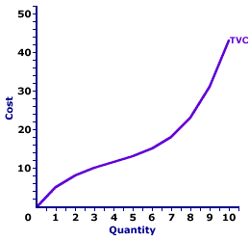

**5(c) Total cost(TC):-**

* **Total cost is the total amount of expenditure incurred by a firm to produce a given level of output.**
* **Thus by adding the total fixed cost and total variable cost, we get Total cost.**

**TC= TFC + TVC**

|  |  |  |  |
| --- | --- | --- | --- |
| **Output units** | **TFC** | **TVC** | **TC** |
| **0** | **20** | **0** | **20** |
| **1** | **20** | **4** | **24** |
| **2** | **20** | **7** | **27** |
| **3** | **20** | **10** | **30** |
| **4** | **20** | **13** | **33** |
| **5** | **20** | **15** | **35** |

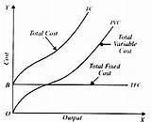

1. **Average cost:-**

* **Average cost incurred by a firm is defined as the total cost per unit of output.**
* **It is the total cost of producing one unit of commodity.**
* **We calculate it as:-**

**AC= AFC + AVC**

**AC= Average cost, TC=Total cost, Q=units of output**

* **Average cost is composed of two types of cost:-**
  1. **Average Fixed Cost (AFC)**
  2. **Average Variable Cost (AVC)**

**6(i). AFC:-**

* **It is defined as the total fixed cost per unit of output.**
* **It’s the ratio of TFC to output (Q):- AFC= TFC/Q**

|  |  |  |
| --- | --- | --- |
| **Quantity of Output (Q)** | **TFC** | **AFC**  **(TFC/Q)** |
| **0** | **20** | **-** |
| **1** | **20** | **20** |
| **2** | **20** | **10** |
| **3** | **20** | **6.67** |
| **4** | **20** | **5** |
| **5** | **20** | **4** |

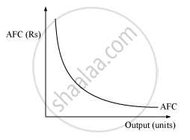

**6(ii). AVC:-**

* **Average variable cost is defined as total variable cost per unit of output.**
* **We calculate it as:- AVC= TVC/Q**

|  |  |  |
| --- | --- | --- |
| **Quantity of O/P (Q)** | **TVC** | **AVC (TVC/Q)** |
| **0** | **0** | **-** |
| **1** | **4** | **4** |
| **2** | **7** | **3.5** |
| **3** | **10** | **3.33** |
| **4** | **13** | **3.33** |
| **5** | **15** | **3** |

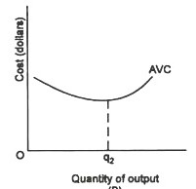

**RELATIONSHIP BETWEEN AC, AFC & AVC**

**AC is the sum total of AFC &AVC**

**AC=AFC+AVC**

|  |  |  |  |
| --- | --- | --- | --- |
| **Qnty. Of O/P (Q)** | **AFC** | **AVC** | **AC** |
| **0** | **-** | **-** |  |
| **1** | **20** | **4** | **24** |
| **2** | **10** | **3.5** | **13.5** |
| **3** | **6.67** | **3.33** | **10** |
| **4** | **5** | **3.33** | **8.33** |
| **5** | **4** | **3** | **7** |

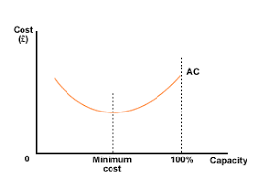

**Economies of scale**

* It refers to the advantages or benefits enjoyed by a firm or industry following an expansion of its scale of production
* The advantage arises due to the inverse relationship between per-unit fixed cost and the quantity produced. The greater the quantity of output produced, the lower the per-unit fixed cost. Economies of scale also result in a fall in average variable costs (average non-fixed costs) with an increase in output.
* It is also regarded as the benefits of large scale of production.
* There are two types of economies of scale.

**External Economies**

**Internal Economies**

**Internal Economies of Scale**

* When a particular firm of an industry enjoys certain advantages following an expansion in its scale of production
* The advantages will be as internal economies of scale
* Different economies of scales are following:-

1. **Financial economies:-**

  Most of the companies rely on borrowed funds, so as to fulfill their need for money to finance the day to day operations and procurement of assets. When a firm is large enough, its creditworthiness is also high, which facilitates them in borrowing funds at a comparatively lower rate of interest.

**2. Technical Economies:-**

Technical economies have their influence on the size of the firm. Generally, these economies accrue to large firms which enjoy higher efficiency from capital goods or machinery. Bigger firms having more resources at their disposal are able to install the most suitable machinery. Therefore, a firm producing on large scale can enjoy economies by the use of superior techniques.

**3. Managerial Economies:-**

Managerial Economies of Scale occurs when the company employs highly qualified, competent and trained managerial personnel, who can work efficiently and effectively along with taking quick, sound and gainful decisions for the firm. It also arises out of specialization. Specialization of management functions means dividing the management of the company into various departments, under specialized personnel, such as production manager, marketing manager, human resource manager, purchase manager, sales manager, etc.

**4. Market Economies:-**

A big firm will generate a higher demand for raw material compared to small firms. The firm can get rebates by suppliers on bulk purchases. A big firm may also undertake expensive surveys of market demand for its products.

**5. Risk-Bearing Economies:-**

* Large scale firms can easily bear the risk.
* A big firm can produce a no. of commodities
* If the demand for a particular product goes down in the market. The big firm still can fallback upon the other products.
* They can easily cover the loans ensured by one or more units.

**6. Labor related economies:-**

* The big firm has a large market for its products.
* It can go in a big way for division of labor & specialization. Such a firm can offer various incentives like- rapid promotion, gratuity etc. to increase efficiency of labor-force.

**7. Economies in transport and storage:-**

It takes place when the firm optimally utilizes its transportation and storage facilities, as these two are required when the raw material comes in and also when the finished goods go out, to/from the firm.

**External Economies of scale**

* In external economies of scale, the company does not gain cost advantage because of its own efforts, rather it is gained due to the expansion and growth of the industry, market or economy, of which the firm is a part.
* It refers to the economies or benefits enjoyed by all firms which are generated by the industry as whole.
* These are associated with the benefits of localization of industry.
* Sualkuchi is the centre of the silk industry of Assam.
* As & when the no. of loom increases, iot may be possible to establish a sophisticated coloring and calendaring plant at Sualkuchi.
* This will benefit all the weavers.

This is an example of external economies of scale.

**External economies can be analyzed in following way:-**

1. **Economies of concentration:-**

* When firms concentrate in a specific area they can get the benefits of several aspects.
* These aspects may be skilled labor, better transport facilities, tax benefits etc.

1. **Economies of information:-**

* When a large scale industry publishes the reports, statistics & other information regarding the products, markets, future aspects and other related matters by its survey & research.
* Firms concentrated nearby can avail these necessary information and use them.

**3. Economies of welfare:-**

* Welfare policy of one firm compels the others to adopt sufficient measures for the welfare of the workers and their families.
* Besides all firms can work together to bring welfare of the whole community.

**Profit analysis**

**Concept of profit:-**

The term profit has different meanings for different people like economist, businessman, entrepreneur etc.

“Profit simply means income over and above your all expenses.”

In accounting, profit is excess of revenue after all expenses of business. But in economics, profit is reward of entrepreneur’s effort of combining all factors of production and bearing risk of uncertainty. Profit in economics is termed as a pure profit or economic profit or just profit.

**Profit differs from the return in three respects namely:**

a. Profit is a residual income, while return is a total revenue

b. Profits may be negative, whereas returns, such as wages and interest are always positive

c. Profits have greater fluctuations than returns

**Types of Profit:**

**On the basis of fields, profit can be classified into two types, which are explained as follows:**

**i. Accounting Profit:**

* Refers to the balance of total income of an organization after deducting all expenses and costs, including both manufacturing and overhead expenses. The cost generally include explicit costs. The accounting profit is used for determining the taxable income of an organization and assessing its financial stability.

**The accounting profit is calculated as:**

**Accounting Profit= TR-(W + R + I + M) = TR- Explicit Costs**

TR = Total Revenue

W = Wages and Salaries

R = Rent

I = Interest

M = Cost of Material

**ii. Economic Profit:**

Unlike the accounting profit, economic profit consider both the costs i.e. explicit and implicit costs while calculating profit.

**The economic profit is calculated as:**

**Economic profit = Total revenue-(Explicit costs + implicit costs)**

**Alternatively, economic profit can be defined as follows:**

**Pure profit = Accounting profit-(opportunity cost + unauthorized payments, such as bribes)**

Economic profit is not always positive; it can also be negative, which is called economic loss. Economic profit indicates that resources of a business are efficiently utilized, whereas economic loss indicates that business resources can be better employed elsewhere.

**Theories of Profit:**

Profits of businesses depend on the successful management of risks and uncertainties by entrepreneurs. These risks can be cost risks due to change in wage rates, prices, or technology, and other market risks. Different economists have presented different views on profit.

**Some of the most popular theories of profit are:**

1. **Walker’s Theory of Profit (Profit as Rent of Ability):**

An American economist, Prof F. A. Walker propounded the theory of profit, known as rent theory of profit. According to him “as rent is the difference between least and most fertile land similarly, profit is the difference between earnings of the least and most efficient entrepreneurs.” He advocated that profit is the rent of exceptional abilities that an entrepreneur possesses over others.

Thus, profit is also said to be the reward for differential ability of the entrepreneur. While formulating this theory, Walker assumed the condition of perfect competition in which all organizations are supposed to have equal managerial ability.

**2. Clark’s Dynamic Theory:**

Clark’s dynamic theory was introduced by an American economist, J.B. Clark. According to him, profit does not arise in a static economy, but arise in a dynamic economy. A static economy is characterized as the one where the size of population, the amount of capital, nature of human wants, the methods of production remain the same and there is no risk and uncertainty. Therefore, according to Clark, only normal profits are earned in the static economy. However, an economy is always dynamic in nature that changes from time to time.

According to Clark, the role of entrepreneurs in a dynamic environment is to take advantage of changes that help in promoting businesses, expanding sales, and reducing costs. The entrepreneurs, who successfully take advantage of changing conditions in a dynamic economy, make pure profit.

**3. Hawley’s Risk Theory of Profit:**

The risk theory of profit was given by F. B. Hawley in 1893. According to Hawley, “profit is the reward of risk taking in a business.

According to him, the greater the risk, the higher is the expected profit. The risks arise in the business due to various reasons, such as non-availability of crucial raw materials, introduction of better substitutes by competitors, obsolescence of a technology, fall in the market prices, and natural and manmade disasters. Risks in businesses are inevitable and cannot be predicted. According to Hawley, an entrepreneur is rewarded for undertaking risks.

**4. Knight’s Theory of Profit:**

According to the theory, profit is a reward for the uncertainty bearing and not the risk taking. Knight divided the risks into calculable and non-calculable risks. Calculable risks are those risks whose probability of occurrence can be easily estimated with the help of the given data, such as risks due to fire and theft.

The calculable risks can be insured. On the other hand, non-calculable risks are those risks that cannot be accurately calculated and insured such as shifts in demand of a product. These non-calculable risks are uncertain, while calculable risks are certain and can be anticipated.

According to Knight, “risks are foreseen in nature and can be insured”. Thus, risk taking is not a function of an entrepreneur, but of insurance organizations. Therefore, an entrepreneur gets profit as a reward for bearing uncertainties and not for risks that are borne by insurance organizations.